A Raspberry Pi development kit is a comprehensive package that includes all the essential components and accessories needed to start working with Raspberry Pi single-board computers. Raspberry Pi is a popular series of small, affordable, and versatile computers that can be used for a wide range of projects, from learning programming to building IoT devices and multimedia systems. A development kit typically provides everything required to get started, making it an ideal choice for beginners and experienced enthusiasts alike.



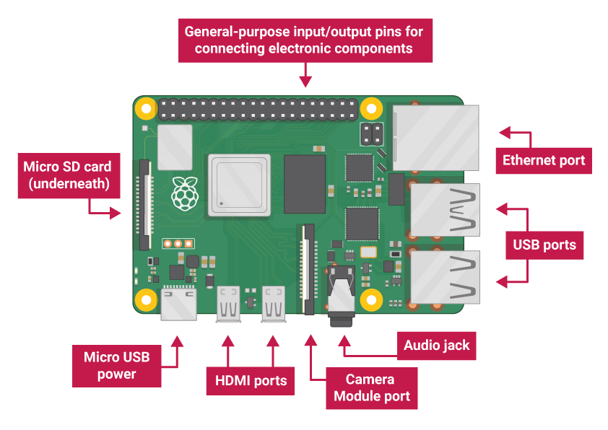

* USB ports — these are used to connect a mouse and keyboard. You can also connect other components, such as a USB drive.
* SD card slot — you can slot the SD card in here. This is where the operating system software and your files are stored.
* Ethernet port — this is used to connect Raspberry Pi to a network with a cable. Raspberry Pi can also connect to a network via wireless LAN.
* Audio jack — you can connect headphones or speakers here.
* HDMI port — this is where you connect the monitor (or projector) that you are using to display the output from the Raspberry Pi. If your monitor has speakers, you can also use them to hear sound.
* Micro USB power connector — this is where you connect a power supply. You should always do this last, after you have connected all your other components.
* GPIO ports — these allow you to connect electronic components such as LEDs and buttons to Raspberry Pi.

**Connect your Raspberry Pi**

Let’s connect up your Raspberry Pi and get it running.

* Check the slot on the underside of your Raspberry Pi to see whether an SD card is inside. If no SD card is there, then insert an SD card with Raspbian installed (via NOOBS).

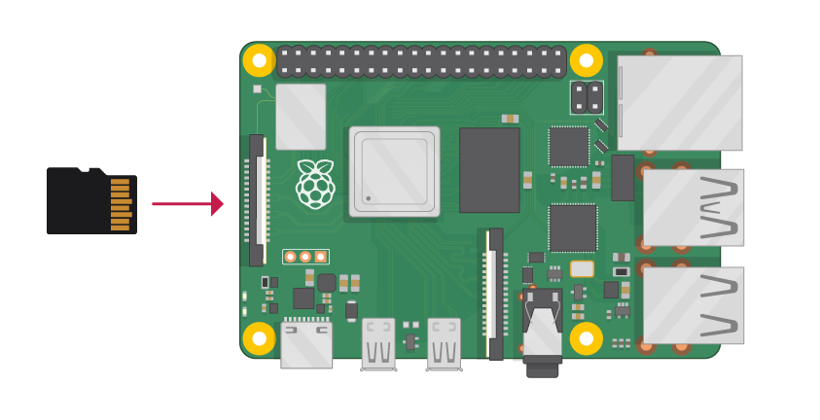

Note: Many microSD cards come inside a larger adapter — you can slide the smaller card out using the lip at the bottom.

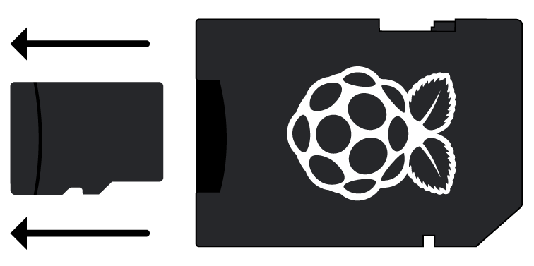

Installing Raspbian using the Raspberry Pi

* Find the USB connector end of your mouse’s cable, and connect the mouse to a USB port on your Raspberry Pi (it doesn’t matter which port you use).

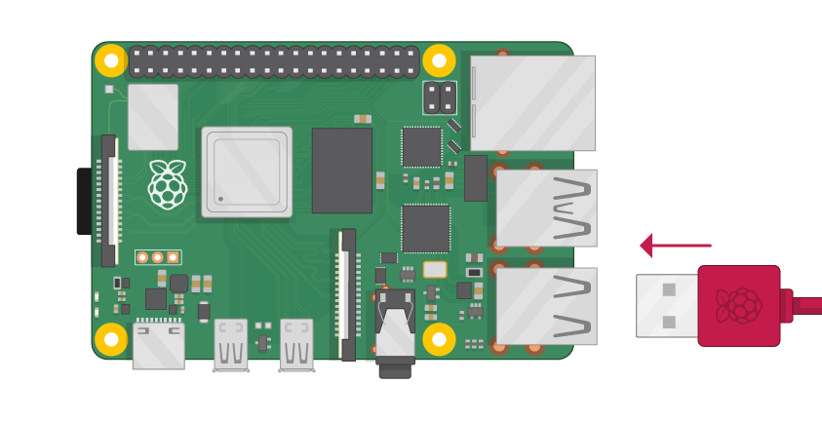

* Connect the keyboard in the same way.

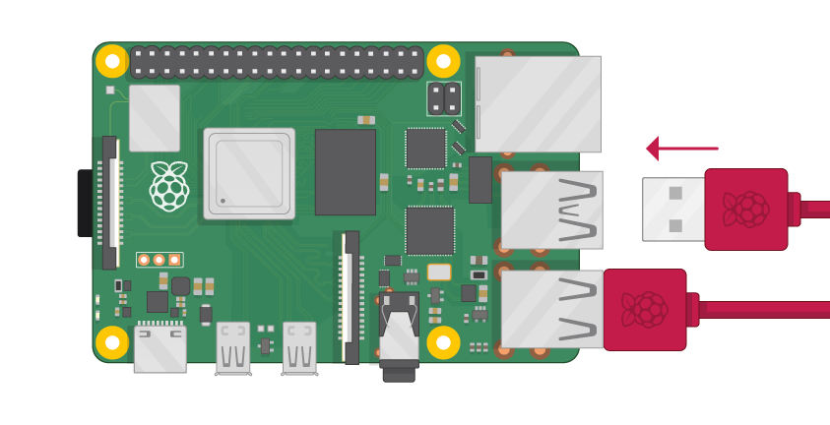

* Make sure your screen is plugged into a wall socket and switched on.
* Look at the HDMI port(s) on your Raspberry Pi — notice that they have a flat side on top.
* Use a cable to connect the screen to the Raspberry Pi’s HDMI port — use an adapter if necessary.

**Raspberry Pi 4**

Connect your screen to the first of Raspberry Pi 4’s HDMI ports, labelled HDMI0.

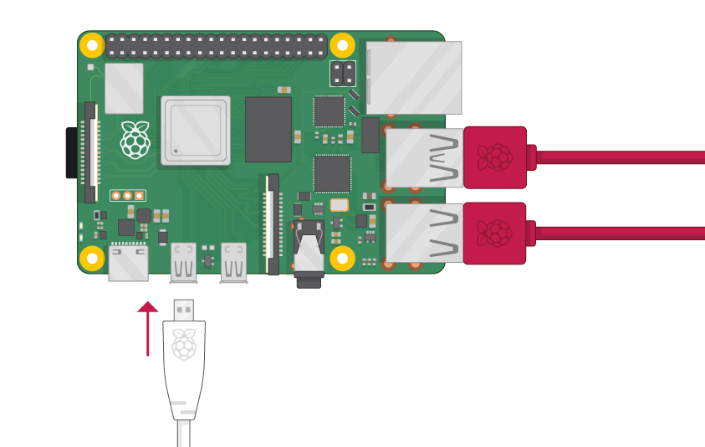

You could connect an optional second screen in the same way.

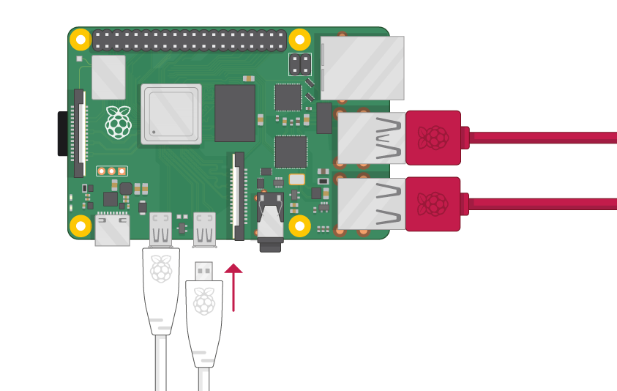

Note: nothing will display on the screen, because the Raspberry Pi is not running yet.

* If you want to connect the Pi to the internet via Ethernet, use an Ethernet cable to connect the Ethernet port on the Raspberry Pi to an Ethernet socket on the wall or on your internet router. You don’t need to do this if you want to use wireless connectivity, or if you don’t want to connect to the internet.

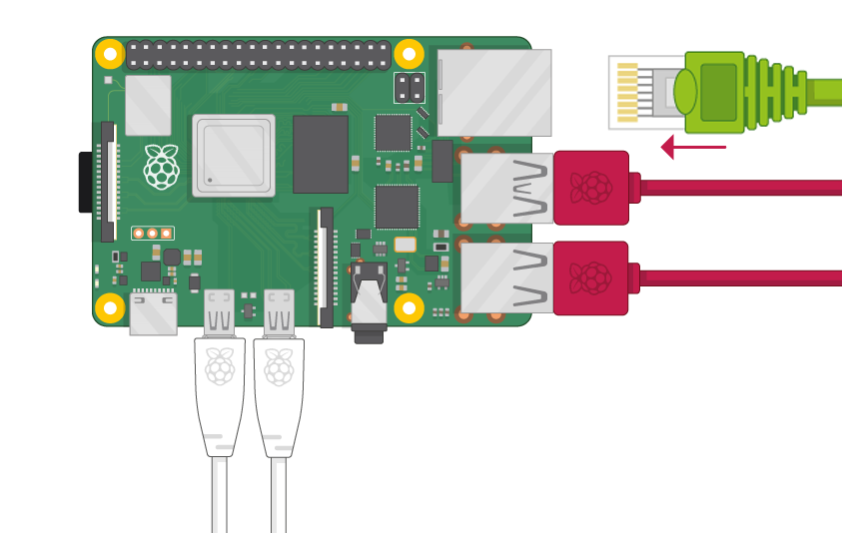

* If your screen has speakers, your Raspberry Pi can play sound through these. Or you could connect headphones or speakers to the audio port.

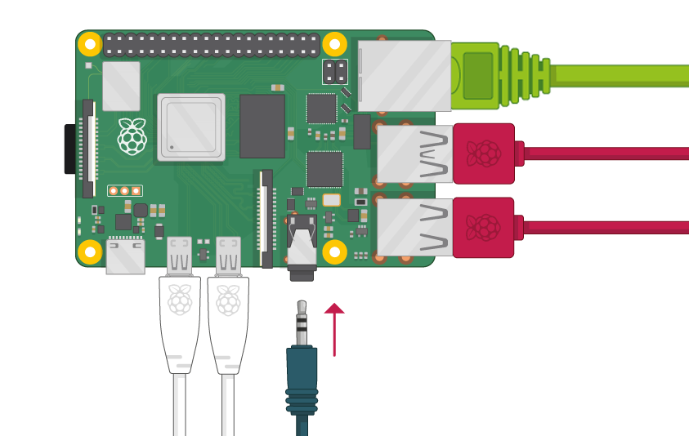

* Plug the power supply into a socket and then connect it to your Raspberry Pi’s USB power port.

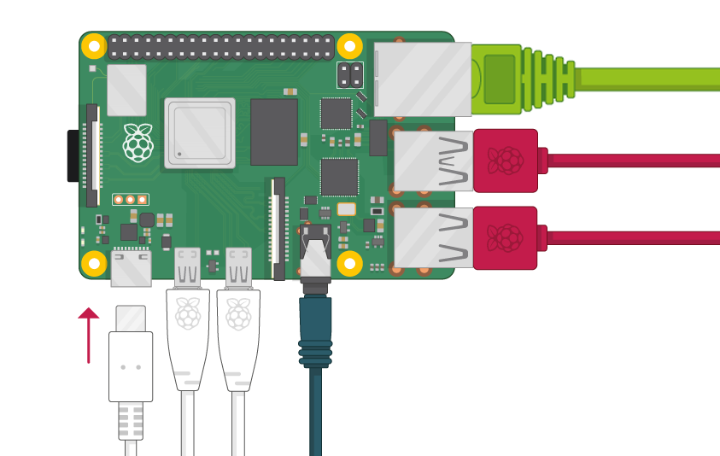

You should see a red light on your Raspberry Pi and raspberries on the monitor.

Your Raspberry Pi then boots up into a graphical desktop.

Here's an extensive explanation of what a Raspberry Pi development kit typically includes and its various components:

**Components of a Raspberry Pi Development Kit:**

* Raspberry Pi Board: The central component of the kit is the Raspberry Pi board itself. This small computer-on-a-board is equipped with a processor, RAM, storage, and various connectivity options.
* Power Supply: A suitable power supply is provided to ensure the Raspberry Pi receives stable and adequate power. It typically includes a micro-USB cable and an adapter.
* MicroSD Card: The operating system and project files are typically stored on a microSD card. The kit includes a pre-installed or blank microSD card, which needs to be inserted into the Raspberry Pi.
* Case or Enclosure: A protective case or enclosure is often included to keep the Raspberry Pi safe from dust, debris, and potential damage.
* Connectivity Cables: Cables like HDMI cables are included to connect the Raspberry Pi to a display or monitor. Other cables might include Ethernet or USB cables, depending on the kit.
* Cooling Accessories: Depending on the model, the kit might include heatsinks or a fan for cooling the Raspberry Pi, especially if it's used in resource-intensive projects.
* GPIO Accessories: Many kits include accessories like breadboards, jumper wires, LEDs, resistors, and other components for experimenting with the Raspberry Pi's GPIO (General Purpose Input/Output) pins.
* User Guide and Documentation: A user guide or manual is often included to help beginners set up their Raspberry Pi and start working on projects. Documentation might include installation instructions, troubleshooting tips, and project ideas.
* Operating System: Some kits include a pre-installed microSD card with a Raspberry Pi-compatible operating system, making it easier to get started without needing to install an OS separately.
* Other Accessories: Additional accessories might be included based on the kit's focus. For example, camera modules, sensors, motor drivers, and other components relevant to specific projects.

**Benefits of a Raspberry Pi Development Kit:**

* All-in-One Solution: A development kit provides all the necessary components in one package, saving time and effort in sourcing individual parts.
* Beginner-Friendly: Kits are designed with beginners in mind, offering step-by-step instructions and ready-to-use components.
* Diverse Learning: Kits encourage learning programming, electronics, and various applications, making them suitable for educational purposes.
* Project Ideas: Many kits include project ideas and resources, inspiring users to explore the full potential of the Raspberry Pi.
* Cost-Effective: Buying a kit can be more cost-effective than purchasing individual components separately.
* Time-Saver: Kits eliminate the need for users to research and select compatible components, reducing setup time.
* Convenience: Having everything needed in one box eliminates the hassle of finding and ordering individual parts.

Raspberry Pi development kits come in various models and configurations, catering to different interests and skill levels. When selecting a kit, consider your intended projects, learning goals, and the specific components included in the kit to ensure it aligns with your needs.